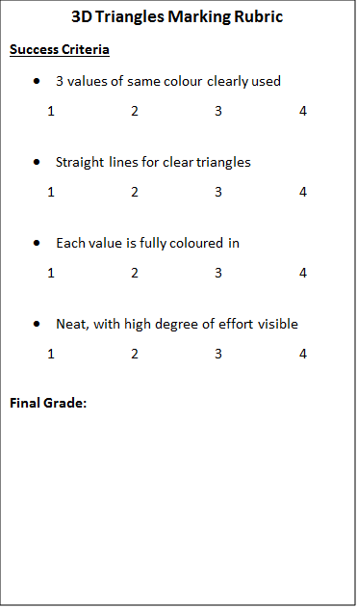Name:_______________________