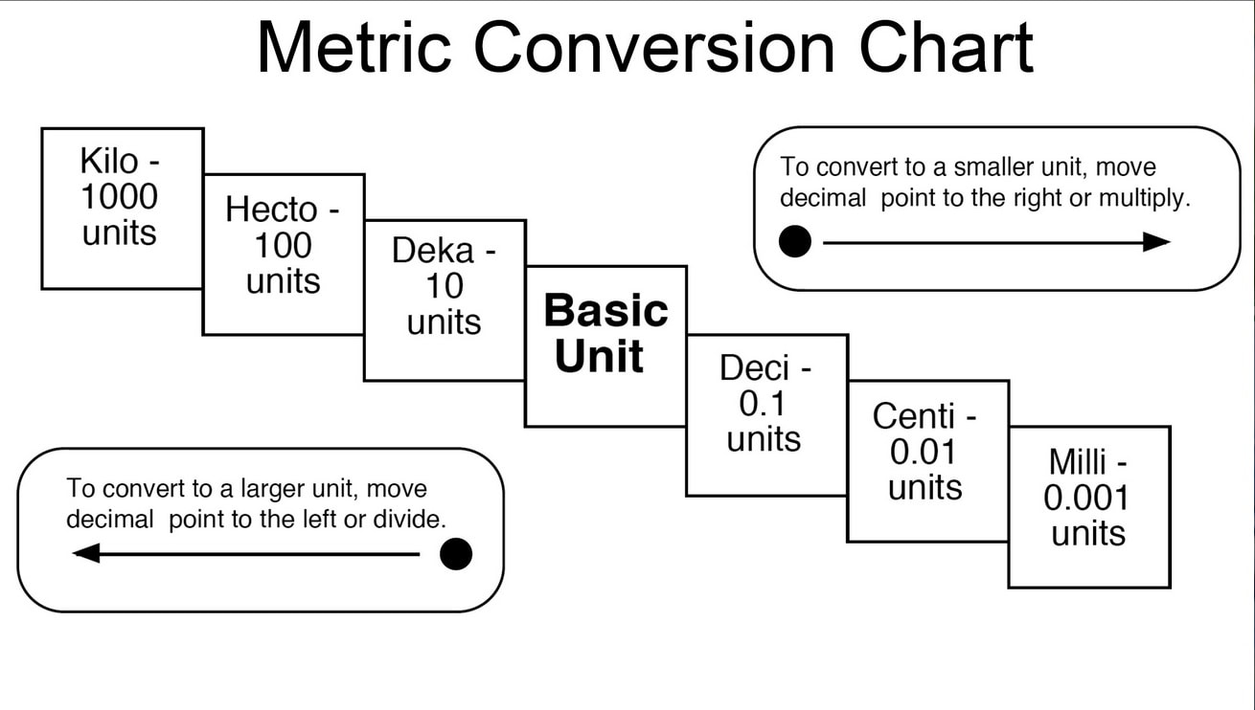
Unit Conversion Practice Problems:

Unit Conversion Word Problems
- Students in a science lab make chemical solutions using water and acid. Find the total amount of solution for each combination, in litres.
- 1L water, 5mL of acid b) 0.5L of water, 2mL of acid

- 0.8L of water and 25 mL of acid d) 0.5L of water and 55.6 mL of acid

- In shop class, students are sent to work in threes to build a wooden track for race cars. In the different groups, some students wrote all their measurements in m, the others used cm and mm. Find the total length of the track for each group in cm. Who has the longest track?
- Group 1 – section 1 is 3406 mm long, section 2 is 2.18 m and section 3 is 55.4 cm long.

- Group 2 – section 1 = 456.7 mm long, section 2 = 87.3 cm long and section 3 = 2.34 m

- Group 3 – section 1 = 0.9 m long, section 2 = 7892 mm long and section 3 = 35 cm

- Group 4 – section 1 = 55.35 cm long, section 2 = 4219.5 mm long and section 3 = 3.1 m

- The gym teacher had the students run the track every day for a week. Sometimes she documented the distance run in m and sometimes she used km. Determine who ran the furthest in km.
Student | Day 1 | Day 2 | Day 3 | Day 4 | Day 5 | Total
Meredith | 1200 m | 2.1 km | 1900 m | 1.2 km | 1600 m
Preston | 3.1 km | 2750 m | 3200 m | 2.8 km | 3100 m
Miranda | 1840 m | 2.2 km | 1.8 km | 2050 m | 2100 m
George | 800 m | 1.1 km | 900 m | 1.2 km | 1150 m

