Patterning Meets Algebra – Independent Note
- When we graphed our patterns, we discovered that they made straight lines. The equation for a straight line is: y = mx+b
- This matches with our pattern, where the m (slope) is our pattern number and b (y-intercept) is the term value at term 0 (ie: where it starts)
- How do you find term 0?
** Subtract the pattern number from term 1

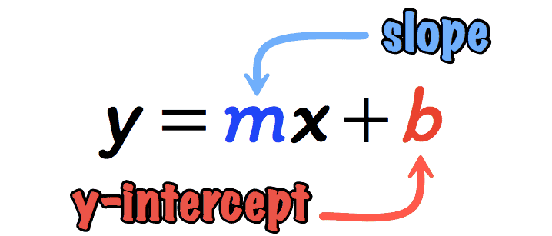

Knowing this information means that we can easily create an equation for each pattern so that we can find term values of the pattern without continuing the pattern. Ie: if I wanted to know what the value at Term Number 100 was, I could use my equation to solve for it instead of writing out the entire pattern.
Example 1:
Term Number | Term Value
0 | 11
1 | 9
2 | 7
3 | 5

Pattern: 9, 7, 5…
- Convert this to a table of values.
9 – (-2)
- Determine what the pattern number is.
-2
- Subtract the pattern number from term 1 to
determine the value at term 0.
- Use this information to replace m and b.

The pattern number is -2. The value at term 0 is 11. Therefore, the equation is y = -2x + 11

Your Turn
Pattern 1: 6, 11, 16 …
Term Number | Term Value
0
1
2
3

- Convert this to a table of values.

- Determine what the pattern number is.

- Subtract the pattern number from term 1 to
determine the value at term 0.
- Use this information to replace m and b.

The pattern number is _____. The value at term 0 is _____. Therefore, the equation is _______
Instructions: for each pattern, determine the equation that could be used to find the nth term. Follow the same steps as the previous pattern.
Pattern 2: 12, 16, 20 …
Term Number | Term Value
0
1
2
3

Pattern 3: 3, 5, 7 …
Term Number | Term Value
0
1
2
3

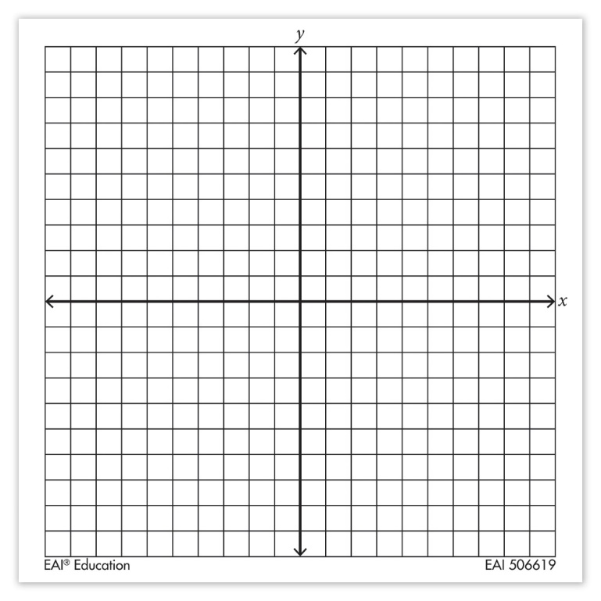
Pattern 4: 3, 8, 13 …
Term Number | Term Value
0
1
2
3

Graph one of the patterns from the above activity.

