Patterning & Algebra – Graphing to Expression
For each set of numbers:

1. Create a table of values for the first terms of this pattern.
2. Extend the table to find the next 2 term values
3. Find the pattern number
4. Graph the pattern
5. Subtract the pattern number from the first term to find b.
5. Figure out the expression to find the nth term
6. Find the 30th term value using the expression.

Term Number (x) | Term Value (y)
1
1
2
3
4
5
6
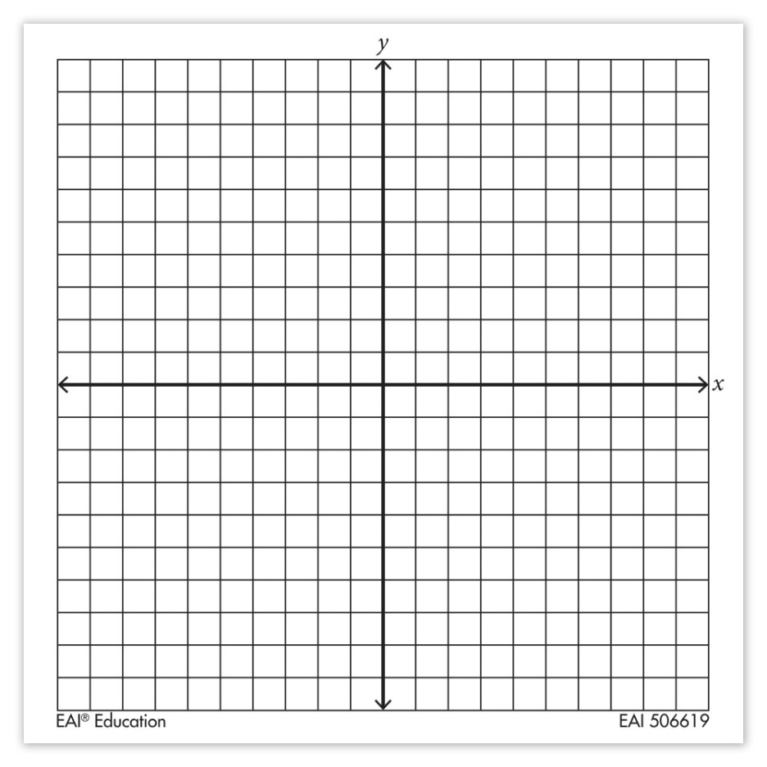
PATTERN 1: 25, 35, 45, 55 …
0

PATTERN 2: 16, 13, 10, 7...
Term Number (x) | Term Value (y)
0
1
2
3
4
5
6
PATTERN 3: 1, 3, 5, 7 ...
Term Number (x) | Term Value (y)
0
1
2
3
4
5
6

PATTERN 4: -9, -15, -21, -27…
Term Number (x) | Term Value (y)
0
1
2
3
4
5
6

