Patterning & Graphing Investigation
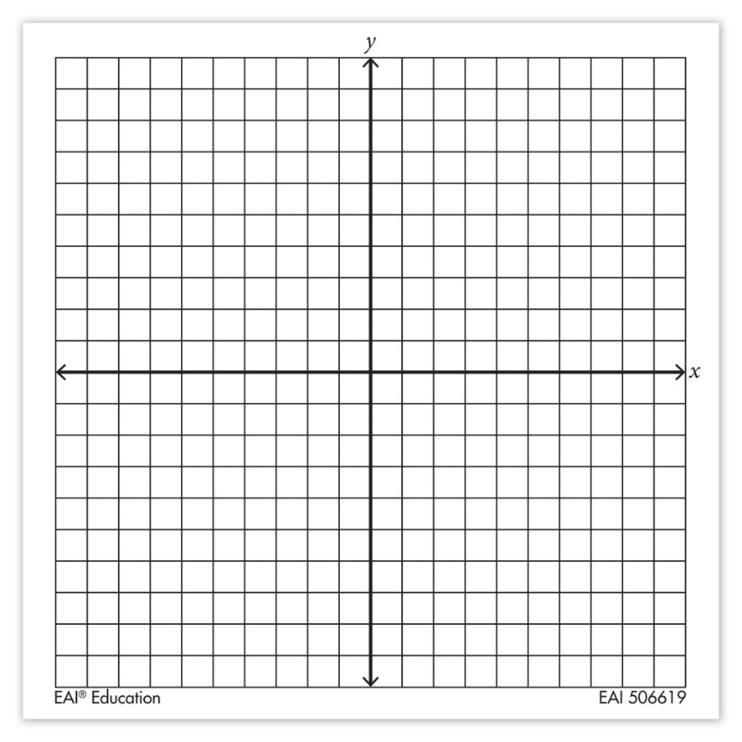
Pattern #1: 5, 9, 13
Step 1: create a table of values using our term numbers as the x- values and the term values as the y-values.
Step 2: determine the pattern number and fill in the next 3 values of your chart
Step 3: plot these values on your graph paper
Term Number (X) | Term Value (Y)

Pattern #2: -3, -7, -11 …
Step 1: create a table of values using our term numbers as the x- values and the term values as the y-values.
Step 2: determine the pattern number and fill in the next 3 values of your chart
Step 3: plot these values on your graph paper
Term Number (X) | Term Value (Y)
Pattern #3: 10, 7, 4 …
Step 1: create a table of values using our term numbers as the x- values and the term values as the y-values.
Step 2: determine the pattern number and fill in the next 3 values of your chart
Step 3: plot these values on your graph paper
Term Number (X) | Term Value (Y)

Pattern #4: -9, -3, 3 …
Step 1: create a table of values using our term numbers as the x- values and the term values as the y-values.
Step 2: determine the pattern number and fill in the next 3 values of your chart
Step 3: plot these values on your graph paper
Term Number (X) | Term Value (Y)

