Patterning Note
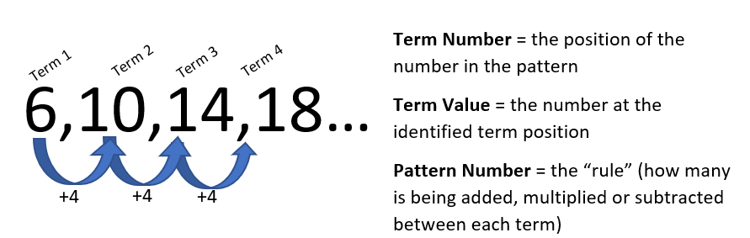
Vocabulary
Term Number:
Term Value:
Pattern Number:

Practice - For each number pattern:
a) find the pattern number b) extend the pattern 3 terms c) find the term value for term number 15

- 6, 12, 18 … | - 4, 2, 0 …
- 21, 29, 37 … | - -8, -5, -2 …
t
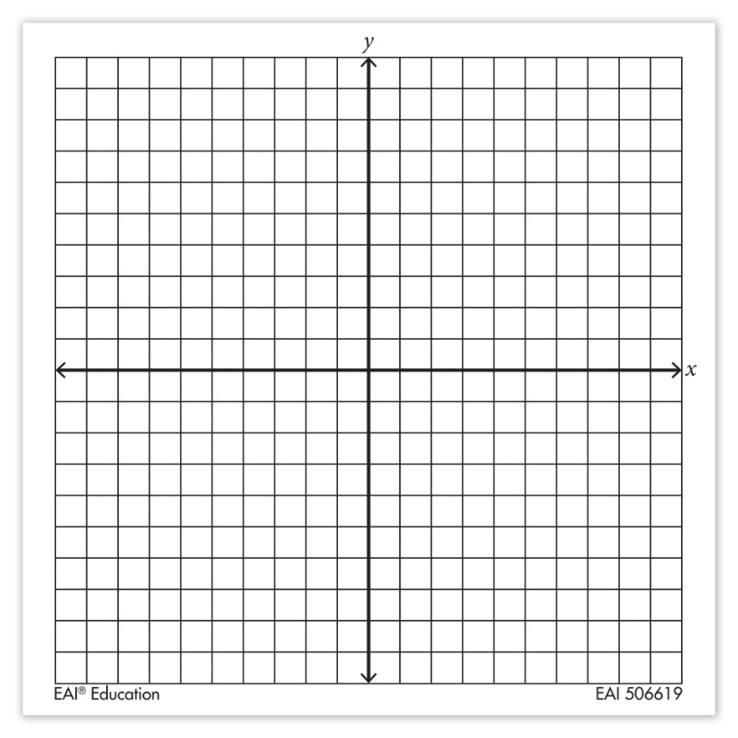
Patterning & Graphing
Step 1: create a table of values using our term numbers as the x- values and the term values as the y-values.
Step 2: determine the pattern number and fill in the next 3 values of your chart
Step 3: plot these values on your graph paper
Term Number (X) | Term Value (Y)

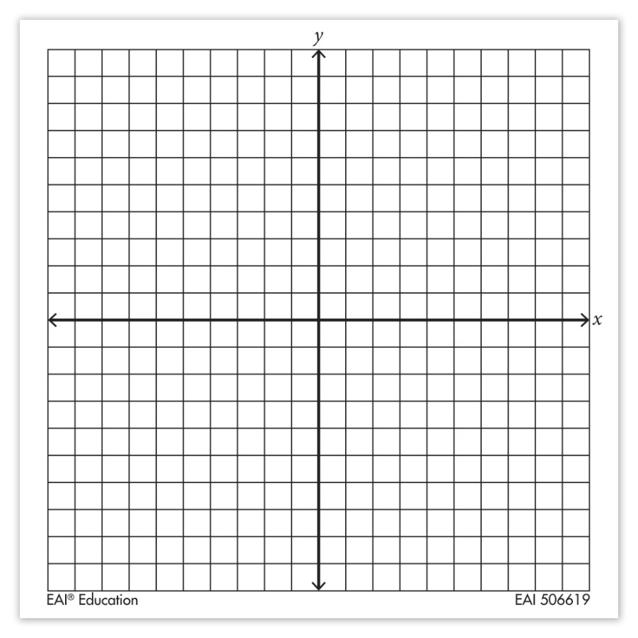
Number of Days | Number of Needles
1
2
3
4
5
6
7
14
30

